Pol Risk Management

Revision History
Version | Date | Author | Reviewer | Approver | Change Summary

Contents

1 Purpose 3
2 Scope 3
3 Terms and Definitions 3
4 Policy Statement 4
5 Risk Response Strategies for Enterprise Risk Management: 5
5.1 Risk avoidance: 5
5.2 Risk reduction 5
5.3 Alternative actions 5
5.4 Share or insure 5
5.5 Risk acceptance 5
6 Core Elements of an Enterprise Risk Management ay <ORG NAME> 5
7 Types of Risks to be Managed by <ORG NAME> at an Enterprise level: 6
8 Implementation of ERM at <ORG NAME> 7
9 Risk Analysis process 9
10 Responsibilities of Risk Oversight Committee 9
11 Developing the Organizational RISK Matrix 10

Purpose
This policy is framed to set up a framework for risk assessment and minimization procedures. The main objective of this policy is to ensure sustainable business growth with stability and to promote a pro-active approach in reporting, evaluating and resolving risks associated with the business. In order to achieve the key objective, the policy establishes a structured and disciplined approach to Risk Management, in order to guide decisions on risk related issues. The organization through its Risk Management process attempts to systematically identify, quantify, and manage all risks and opportunities that can affect achievement of a corporation’s strategic and financial goals.
The specific objectives of the Enterprise Risk Management Policy are:
- To ensure that all the current and future material risk exposures of the company
are identified, assessed, quantified, appropriately mitigated, minimized and
managed i.e. to ensure adequate systems for risk management.
- To establish a framework for the company’s risk management process and to
ensure its implementation.
- To enable compliance with appropriate regulations, wherever applicable, through the adoption of best practices.
- To assure business growth with financial stability.

Scope
Applicable to all employee, customer, vendor, contractor, consultant, trainee, faculty, or any other individual who have access to any of the Information or Information Processing Facilities like Servers, Networks, Applications, Databases, Desktops, Laptops and any printed or hardcopy of information.

Terms and Definitions
Terms | Definition
Risk ID | A Unique name or ID number to identify the risk
Risk Source | Mention the source of risk. How this risk was arrived or identified.
Risk owner | The person or entity with the accountability and authority to manage a risk.
Risk Rating | Calculation method for risk value
Likelihood | Enter the likelihood that the risk would occur if it was totally untreated by using the numeric value between 1 to 5  (If the Likelihood is 1, then it is Rare -Although they are conceivable, we will probably never experience incidents of this nature.  If 2, then it is Unlikely - Incidents of this nature are uncommon but there is a genuine chance that we may experience them at some future point.  If 3, then it is Possible - It is distinctly possible that we will experience incidents of this nature.  If 4, then is Probable - We are likely to experience incidents of this nature before long.  If 5, then it is Almost certain - We are bound to experience further incidents of this nature -in fact they are probably occurring right now!)
Impact | Enter the potential business impact if the risk occurred without any treatment, as a numeric value between 1 to 5  If the Impact is 1, then it is Insignificant - Minimal if any operational impact, negligible costs.  If the Impact is 2, then it is Minor - Noticeable but limited operational impact.  If the Impact is 3, then it is Moderate - Substantial operational impact, very costly.  If the Impact is 4, then it is Major - Severe loss of operational capability, highly damaging and extremely costly but survivable.  If the Impact is 5, then it is Extreme - Complete operational failure, extreme impact, un-survivable.
Risk Value | This is the product of the Information/Objective rating values, likelihood and impact.
Risk Level | This is based on the risk value  ( If Risk value 1-4, then New Risk Level is Low  If Risk value 5-9, then New Risk Level is Medium  If Risk value 9-15, then New Risk Level is Medium to High  If Risk value 16-25, the New Risk Level is Very High)
Risk Treatment Options | Select the Risk Treatment Options based on the Risk Rating. Risk Treatment options are Treat, Avoid, Accept and Transfer.
Control Reference/Clause | List all the applied control reference/clauses to mitigate the identified risk as per the ISO 27001:2013/QMS 9001:2008 standard and SOC2
Residual Risk rating | Calculation method for risk value by taking the existing controls in to consideration

Policy Statement
In principle, risk always result as consequences of activities or as a consequence of
non-activities. Risk Management and Risk Monitoring are important in recognizing
and controlling risks.
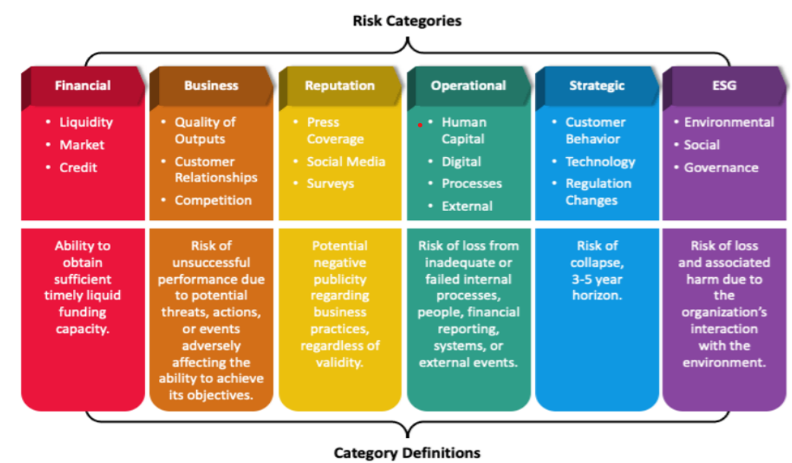

Risk Response Strategies for Enterprise Risk Management:
5.1 Risk avoidance: The elimination of risks or activities that can negatively impact the organization’s assets. For example, the cancellation or halt of a proposed production or product line.
5.2 Risk reduction: The mitigation or limitation of the severity of losses. For example, management can plan frequent visits to their major suppliers to identify potential problems early.

5.3 Alternative actions: The consideration of other possible ways to reduce risks.

5.4 Share or insure: The actions of transferring risks to third parties, like insurance agencies. For example, buying an insurance policy that could cover any unexpected loss for the business.

5.5 Risk acceptance: The acknowledgment of the identified risks and the willingness to accept their consequences. Typically, any loss from a risk not covered or avoided is an example of risk acceptance.

Core Elements of an Enterprise Risk Management ay <ORG NAME>
ERM at <ORG NAME> follows a very distinct and ongoing process, where it actively identifies and reassesses the various strategic and major risks to ensure financial security for businesses. The process includes five specific elements:

- Strategy/Objective setting: Understand the strategies and associated risks of the business.
- Risk identification: Provide a clear profile of major risks that can negatively impact the company’s overall financials.
- Risk identification: Provide a clear profile of major risks that can negatively impact the company’s overall financials.
- Risk assessment: Identified risks are strictly analyzed to determine both their likelihood and potential.
- Risk response: Consider various risk response strategies and select appropriate actionable paths to align identified risks with management’s risk tolerances.
- Communication and monitoring: Relevant information and data need to be constantly monitored and communicated across all departmental levels.

Types of Risks to be Managed by <ORG NAME> at an Enterprise level:
- Compliance risk
Government bodies have in place an array of industry laws, regulations, policies and best practices in place to ensure ethical business practices. Not complying with these obligations can present great financial and legal implications for organizations, posing risks to achieving business objectives and operating in general. That said, in today's globally interconnected and fast-paced world, rules and regulations can change quickly and the legal frameworks can be difficult to navigate.
- Financial risk
With the organization’s expansion internationally, fluctuating exchange rates impose a financial risk that is considered, since they affect the currency amount received by the organization. Ultimately, the goals of any organization cannot be achieved without sound financial management and it is crucial to anticipate financial risks, assess the impact of those risks and be prepared to react to or avoid adverse events.
- Strategic risk
While the day-to-day operations of your organization are important, managing your organization’s strategic goals is just as fundamental to future success. Strategic risks refer to external causes or circumstances that, if they were to occur, would be serious enough to alter the strategic direction of your business, impacting its future success or failure. All organizations are open in varying degrees to strategic opportunities and threats. Exploring how such changes might affect your organization will help mitigate the issues that might be created.
- Operational risk
Although day-to-day operations are often tried and tested to minimize dangers, incidents or unexpected circumstances could still take place, as the last several months have made blatantly clear. Operational risk refers to the risk of loss resulting from failed internal processes, people or systems or external events. Examples include global crises, IT systems failure, data breaches, fraud, loss of people and litigation, among others. Organizations, therefore, must know the daily functions, processes and systems that are critical to their business operating normally and have plans and procedures in place to manage those risks and ensure 'business as usual'.

- Environmental Social Governance risk
General health and safety risks can be presented in a variety of forms, regardless of whether the workplace is an office or construction site. The key is identifying the types of hazards that could occur, such as physical, ergonomic, chemical and biological, assessing the risks and putting the appropriate control measures in place to make sure that your employees feel safe and taken care of, physically and mentally. The best workplace health and safety measures offer the greatest amount of protection and the most reliability.
- Reputational risk
All businesses have a reputation to maintain, with their stakeholders, including investors, employees and of course, customers. Decisions made by organizations, as well as incidents where they are liable, can create negative press and significantly affect brand perception. Reputational risk has become of even greater concern for organizations in recent years due in large part to the rise of social media, which allows for almost immediate global communications that make it more challenging for companies to control how they are perceived. Understanding threats to your reputation and how to manage those situations is a must.

Implementation of ERM at <ORG NAME>

If you approach ERM as a business strategy with specific goals, you’ll find your chances of success much improved. Here’s how to set up and run an ERM program in five steps.

Step 1: Establish Organizational Objectives

Before beginning the risk assessment process, your organization must determine its business goals. The business objectives should govern all functions, so risk reviews consider corporate goals.

Risk mitigation strategies can strengthen your profitability by improving your business performance. Unexpected events (especially cyber-attacks) reduce operational efficiency. As a result, you might lose customers and face higher employee remediation costs.

If you think only about profits, though, you’ll overlook the number-one hidden benefit of risk management: client and customer confidence. Security-savvy people and organizations will stick with you if they know you’re working hard to protect their data and security.

When you set your organizational objectives, review your current risks and any threats from new revenue streams.

With the organizational growth, and changing risk landscape and posture understanding the organizational objectives before assessing risks has increased the value of the risk mitigation process.

Step 2: Assess the Risks

A critical step in any ERM program is an assessment of your enterprise’s vulnerabilities.

Risk assessment starts with reviewing assets. Organizational financial, customer, physical, employee, supplier, and organizational assets determine what is required to protect and how to protect it.

Post asset review, risk analysis is performed to examine how opponents can exploit them. To strengthen your risk management, you must recognize ways that opponents (or malicious attackers) can use even your best defenses to their advantage.

Step 3: Determine Risk Acceptance or Risk Avoidance
After a risk assessment, risk management teams must then decide whether to accept or avoid the risk. When reviewing the organization IT landscape, the risk management mechanism looks at the controls in place to accept or avoid risks based on the risk assessment and assets.

Step 4: Map Internal and External Risks
Mapping internal and external risks throughout the enterprise gives a valuable insight into where and how those risks might intersect.

That external risk bearer like the third-party vendors or suppliers might affect the internal risks of cash flows and reserves. Mapping those connections and consequences lets management teams understand where risks might spring from and how to address them more effectively and efficiently.

Step 5: Set Controls and KRIs
To remain compliant with regulations and frameworks, you must continuously monitor risks and metrics. Controls are implemented to keep risks in check, and key risk indicators (KRIs) to alert managers when those risks are rising to unacceptable levels.

When KRIs do drift into “the red zone,” that could mean either a control has stopped working, or the underlying risk has changed in some way that leaves the control ineffective. Regardless, controls and KRIs serve as an early-warning system to alert managers that something in the risk management program needs attention.

Risk Analysis process

Responsibilities of Risk Oversight Committee

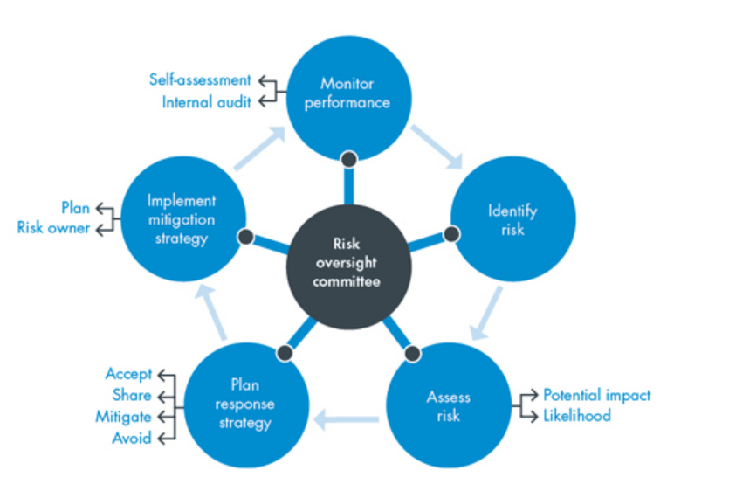

Developing the Organizational RISK Matrix

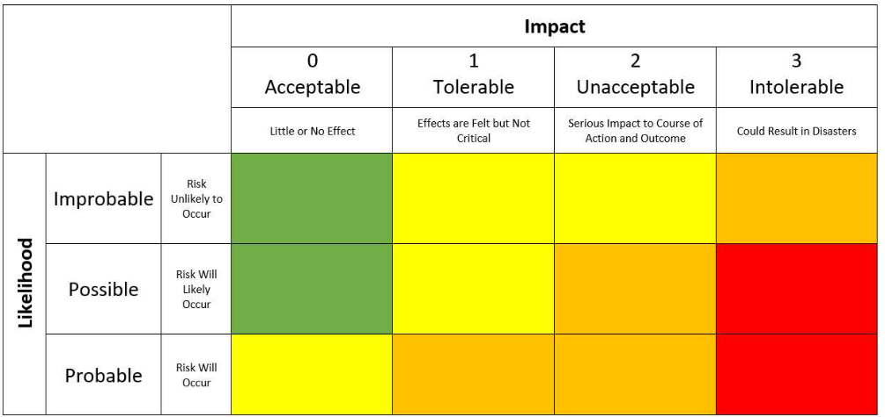
1. The first step in developing a risk matrix is to make a list of all the risks based on the risk categories within the organization.
2. The next step is to take the list of risks that is identified in the previous step and add the likelihood that the risk may occur to each one. Risk likelihood can be divided into three categories:
Probable – Very likely to happen
Possible – Some chance of happening
Improbable – Small chance of happening
3. Next, look and each risk and determine its impact to the business if it were to happen. Risk impact can be divided into four categories:
- 0 – Acceptable – little to no effect on the business
- 1 – Tolerable – effects are felt but do not seriously affect the business
- 2 – Unacceptable – causes major disruption to the business
- 3 – Intolerable – business may not recover
- 4. Based on the likelihood and impact of each risk. place each risk into a Risk Matrix.

